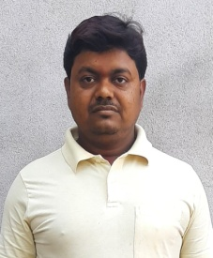**RESUME**

**AWADHESH KUMAR BOSAK**

**+91 79033 11771**

**Email Id:** [**awadheshkrbosak1977@gmail.com**](mailto:awadheshkrbosak1977@gmail.com)

**OBJECTIVE**

To work with an organization where can learn new skills and increase my abilities for the organizational

goals as well as myself.

**EDUCATIONAL QUALIFICATIONS**

* Passed out 12th from JAC
* Passed out 10th from BSEB

**TECHNICAL KNOWLDEGE & SKILLS**

* Basic knowledge of computer
* Rural Development and Land Reforms Survey Committee, Patna
* First –Aid Veterinary Training Programme

**STRENGTH & HOBBIES**

* Hard & Smart Working
* Honest & Punctual
* Good Communication Skill
* Social Service

**PERSONAL DETAILS**

Father’s Name : Shri. Joydeo Chaandra Das

Mother’ s Name : Meena Devi

Gender : Male

D.O.B : 22-02-1977

Address : Ward.no. 44, Belouri Purnea, pin code: 854326

Marital Status : Married

Caste : SC (HINDU)

Date:………/…………/……………… (Awadhesh Kumar Bosak)